Member ID: ____________________
Time: ___________________
Rank: _______________



JAVA PROGRAMMING
(340)
NATIONAL 2024

PRODUCTION:
Java_National ___________ (460 points)

Industry Certification (50 minutes)
IT Specialist Java

Test Time: 90 minutes

GENERAL GUIDELINES:
Failure to adhere to any of the following rules will result in disqualification:

1. No equipment, supplies, or materials other than those specified for this event are allowed in the testing area. No previous BPA tests and/or sample tests (handwritten, photocopied, or keyed) are allowed in the testing area.

2. Electronic devices will be monitored according to ACT standards.

3. Your name and/or school name should not appear on work you submit for grading.

4. Ensure that the files required to run your program are present and will execute.

5. Once you complete the problem listed below, upload all competition materials (including project files, etc.) to the National BPA Pre-submit System at presubmit.bpa.org.

6. Compress all files in a single archive (zip file) and use the following naming conventions for your documents:

JAVA-MemberID.zip

Assumptions to make when taking this assessment:

- One Java file is provided in the contest folder (SeatingChartBuilderNATL).
- There are two text files in your student folder: NationalStudentNames.txt, and NationalTestRecords.txt
  - NationalTestRecords.txt: these records are organized line by line, with each field being separated by a comma (like a csv. file but instead it is a text file). In addition, the names are listed with an easy to identify call name convention (AlphaFirstName1) that goes in alphabetical order; it is made this way to quickly identify these records
  - NationalStudentNames.txt: this is a linear list of only names separated with commas. The program will randomly create student records from these names
- The goal of the test is to create a program that can do the following:
  - Import two different types of text files, and combine them into one list
  - Find the highest GPA and lowest GPA
  - Sort the records in ascending and descending order based upon GPA
  - Sort the records in ascending and descending order based upon last name
- Each student record once imported will be organized last name, first name, grade level, and GPA.
- When the records are combined, there will be a total of 22 students.
- There will be five sections of output that will automatically print to the console.

Development Standards:

- Your Code must use a consistent variable naming convention.
- All subroutines (if any), functions (if any), and methods (if any) must be documented with comments explaining the purpose of the method, the input parameters (if any), and the output (if any). Readability is a goal of good code.

Commenting for Source Code Review (see the rubric):
- Certain sections of your code will be graded. These gradable blocks of code can range from creating data structures, method algorithms, exception handling, and class construction.
- The grading rubric contains a section called Source Code Review: in this section are listed a description all of the graded programming concepts.
- Each gradable item must have a comment listed at its beginning, and the comment must be prefixed with the comment flag. The flag helps the graders easily locate the code to increase the effectiveness of grading.
- The flag will always use this naming convention: SC# (NOTE: the # symbol will be replaced with sequential numbering, i.e. SC1, SC2, SC3, etc.
- No explanation in the comment with the flag is required, only the comment flag; however, any information placed in the comment could help the grader better understand and avoid any costly errors.
- The comment flag needs to be place in close proximity to the block of code it represents.
- If a comment flag is not present, you will not receive credit.
- In this example the Source Code Review has a gradable section of code for printing to the console (remember these are non-related examples):
  - SC12: print method in the main class is printing the correct object ____ 10 pts
  - The user will place the code above the method call:

//SC12 printing the car object
System.out.println(car);

Java_National

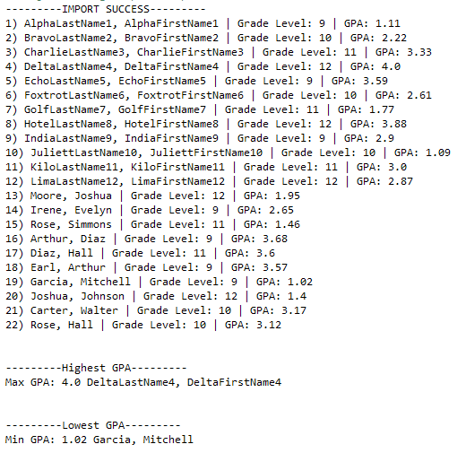
In this test you will be creating another prototype seating chart software for your local school. The program will be designed to import, read, and create student records based upon two different types of text files. One text file will be a list of names only, that the program will create random student records similar to the Java_State contest. The second file will be complete student records that the program must use to create student records. All records should be stored into one data structure. The other action you must take will be designing the program to sort the records in ascending (low to high) and descending (high to low) order based upon the GPA and the last names. All of the outputs will be automatic.

Output 1 General List: This output imports the NationalTestRecords and then imports the NationalStudentNames. After creating the records, the program will discover which record contains the highest and lowest GPA (see image on the right).

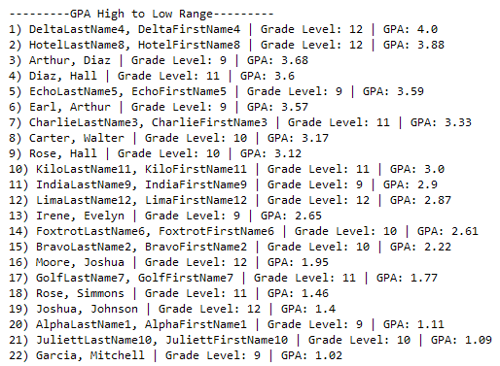
Output 2 GPA High to Low Range: The student records will be sorted from greatest to least (see image to the left).

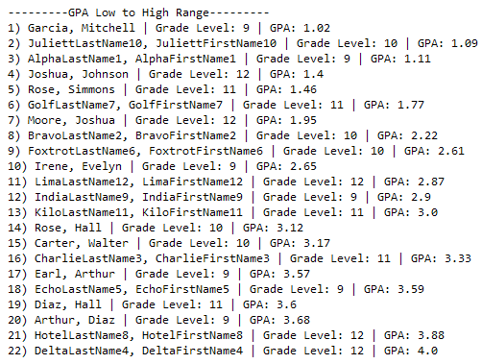
Output 3 GPA Low to High Range: The student records will be sorted from least to greatest (see image to the right).

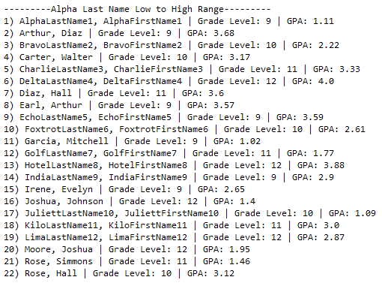
Output 4 Alpha Last Name Low to High Range: The student records will be sorted from least to greatest (see image to the left).

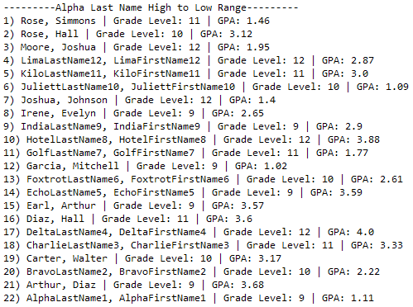
Output 5 Alpha Last Name High to Low Range: The student records will be sorted from greatest to least (see image to the right).

File Read Error (NationalTestRecords.txt): If the NationalTestRecords.txt is not found, the following message should appear and program exits.

File Read Error (NationalStudentNames.txt): If the NationalStudentNames.txt is not found, the following message should appear and program exits.

Solution and Project (There is NO partial credit) (NOTE: UC represents uppercase and LC represents lowercase)
The Java source file is present on the flash drive in a single folder with your contest ID |  | 10 points
Program Execution (If the program does not execute, then the remaining items in this section receive a score of zero)
Output 1 General List displays: first 12 records are from NationalTestRecords, last 10 are random from NationalStudentNames |  | 20 points
Output 1 General List displays correct Max GPA record and Min GPA record |  | 10 points
Output 2 GPA High to Low Range arranges all 22 records in proper order |  | 10 points
Output 3 GPA Low to High Range arranges all 22 records in proper order |  | 10 points
Output 4 Alpha Last Name Low to High Range all 22 records in proper order |  | 10 points
Output 5 Alpha Last Name High to Low Range all 22 records in proper order |  | 10 points
File Read Error (NationalTestRecords.txt) prints to console when file is missing |  | 10 points
File Read Error (NationalStudentNames.txt) prints to console when file is missing |  | 10 points
Subtotal |  | /100 Points

Source Code Review (There is NO partial credit) NOTE: you must place the comment flag in front of the comment in your code in order to get credit. The comment flag will precede the explanation. For example, if the flag is SC1, your comment must read as “#SC1…” in front of the part of the code being reviewed. Code must work to get credit. There is no partial credit.

A comment containing the contestant number is present at the top of the SeatingChartBuilderNATL.java file |  | 10 points
SC1: SeatingChartBuilderNATL.java class: comment data structures declaration and assignment statement of information gathered from NationalTestRecords.txt. Explanation of why this was used is required. |  | 10 points
SC2: SeatingChartBuilderNATL.java class: comment data structures declaration and assignment statement of information gathered from NationalStudentNames.txt. Explanation of why this was used is required. |  | 10 points
SC3: SeatingChartBuilderNATL.java class: comment code with explanation of what file reading strategy was used for NationalTestRecords.txt |  | 20 points
SC4: SeatingChartBuilderNATL.java class readNationalTestRecords method: comment code with explanation of how this method was used to gather data from NationalTestRecords.txt |  | 20 points
SC5: SeatingChartBuilderNATL.java class readNationalTestRecords method: comment code with explanation of how delimiter (,) and numerical data (integers and doubles) was managed to gather data from NationalTestRecords.txt |  | 30 points
SC6: SeatingChartBuilderNATL.java class: comment code with explanation of how to handle NationalTestRecords.txt file NOT being found |  | 20 points
SC7: SeatingChartBuilderNATL.java class: comment code with explanation of what file reading strategy was used for NationalStudentNames.txt |  | 20 points
SC8: SeatingChartBuilderNATL.java class readNationalStudentNames method: comment code with explanation of how this method was used to gather data from NationalStudentNames.txt |  | 20 points
SC9: SeatingChartBuilderNATL.java class readNationalStudentNames method: comment code with explanation of how delimiter (,) and empty spaces were managed to gather data from NationalStudentNames.txt |  | 20 points
SC10: SeatingChartBuilderNATL.java class: comment code with explanation of how to handle NationalStudentNames.txt file NOT being found |  | 20 points
SC11: SeatingChartBuilderNATL.java class print_GPAHightoLow_Range: comment code showing method was used to sort GPA high to low |  | 10 points
SC12: SeatingChartBuilderNATL.java class print_GPALowtoHigh_Range: comment code showing method was used to sort GPA low to high |  | 10 points
SC13: SeatingChartBuilderNATL.java class print_AlphaLowtoHigh_Range: comment code showing method was used to sort last names low to high |  | 10 points
SC14: SeatingChartBuilderNATL.java class print_AlphaHightoLow_Range: comment code showing method was used to sort last names high to low |  | 10 points
Subtotal |  | /240 Points
Total Points |  | /340 Points

